**Team Pwnage**

**Siddhartha Balasubramanian**

**Shaun Lee**

**Mark Duppenthaler**

**Nabil Lathiff**

**Rudy Lam**

**Physics 350 Project Proposal**

**n-Body Gravity Simulator**

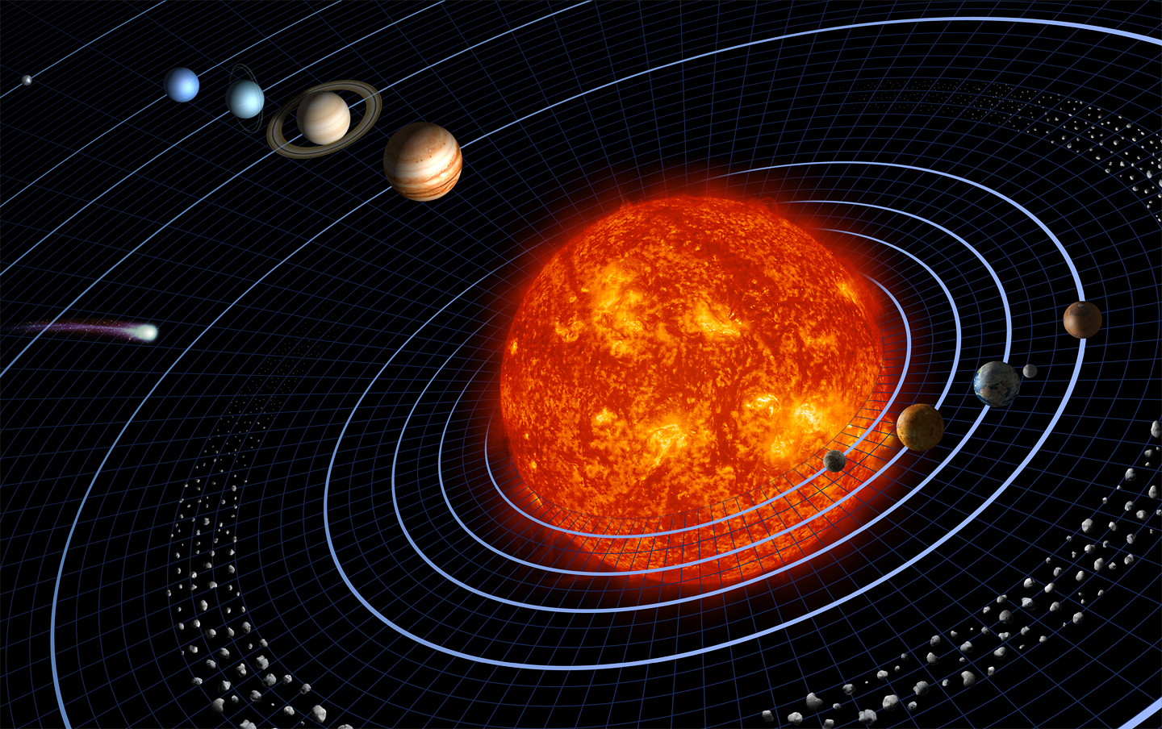

Figure : Our solar System.

Source http://www.nasa.gov/

Introduction

Our group will create a software gravitational physics simulator and visualizer to simulate and display the motions of bodies in any n-body system. Each body’s initial position, initial velocity, mass and radius are specified at the beginning and the simulator will then compute each body’s position at each time step. We plan to demonstrate various physical concepts with this program.

Physics Involved

In this simulation, the following physical concepts are demonstrated:

1. Gravitation

This gives rise to the orbiting motion of planets, stars and galaxies. We will demonstrate the general elliptical orbits that the gravitational force causes.

1. Gauss’s Law for Gravity

The gravitational force is an inverse-square force and hence Gauss’s law is used to calculate the magnitude of the forces on the bodies.

1. Newton’s 2nd Law

The gravitational force will cause each object to accelerate. The magnitude of the acceleration is proportional to the mass of the object, as stated by Newton in the 2nd Law.

1. Kepler’s Laws

Orbital motion is described by Kepler’s laws. The simulation will display characteristic motion such as elliptical orbits.

1. Centripetal Forces

Gravity acts as a centripetal force and gives rise to circular and elliptical orbits. The simulation will demonstrate this force.

The simulator uses the standard inverse-square relationship to calculate the gravitational attraction between two bodies. By tweaking some constants, the same simulator can be used with any inverse-square force. The simulation will be done using numerical integration methods, specifically, Euler’s method.

Although the simulator will display a wide variety of gravitational phenomenon, we do make some simplifying assumptions: First, each planet is assumed to be a spherically symmetric and has a uniformly distributed mass. Secondly, we are only taking into account of the gravitational force and ignoring any other force interactions between the planets.

Testing

The simulator has already been built. What remains now is the graphical visualization system. A rudimentary visualizer was put together for the time being. In this visualize, colored cubes represent bodies. A screen shot of a binary star system with 3 planets is seen in .

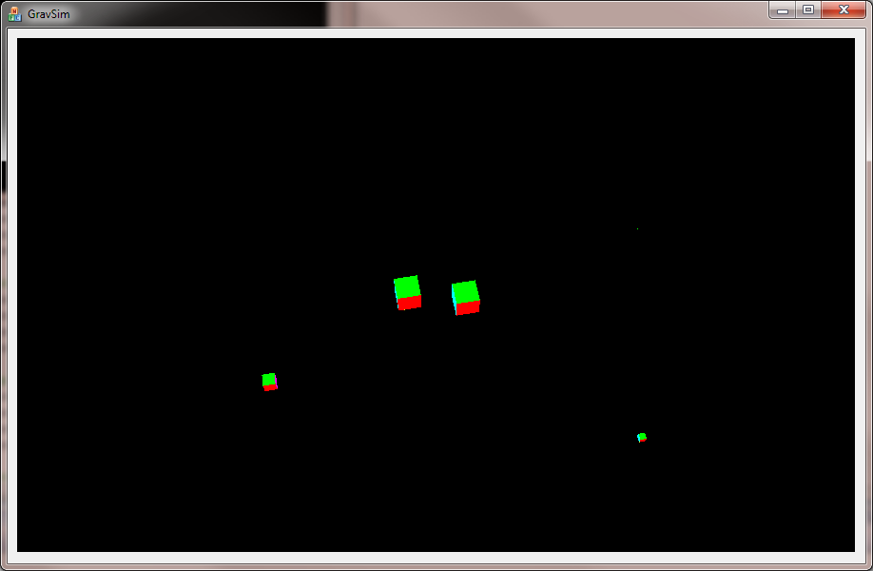

Figure : Simulator showing a binary star system and 3 small planets orbiting them. Objects are represented as colored cubes in this early version of the simulator

User Features

The interface will allow the user to zoom in, pan, and rotate using the mouse pointer so that the system can be looked at from various angles.  The user can also insert and delete planets while the simulation is running to see the effect such changes in the system.

In case the planets collide into each other, we may apply a collision detector system the program will simulate it as an explosion.  We hope, for the final presentation, to simulate a case where there is a black hole in the centre. Other demonstrations we are thinking about doing are multiple-star systems and behavior of satellites.

Video

Please do check out our video showing our current progress at: <http://vimeo.com/9956673>